Points-Am,S-Bolivia-Tolomosa-near Tarija

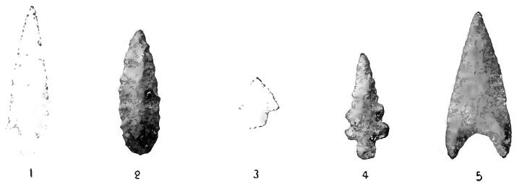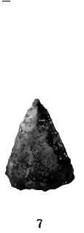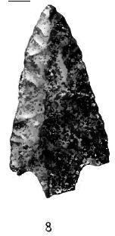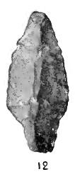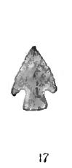

**The archaeological record of the ancient populations of the eastern valleys of the province Arce, Tarija, Bolivia**

## Intersecciones en antropología

## versión ISSN 1850-373X

### Intersecciones antropol. vol.11 no.1 Olavarría ene./jun. 2010

http://www.scielo.org.ar/scielo.php?script=sci_arttext&pid=S1850-373X2010000100005

**Beatriz Ventura, Philippe Delcourt, Gabriela Ortiz, Lilo Methfessel, Catriel Greco, Weimar Buitrago and Freddy Paredes**

Beatriz Ventura. CONICET, Institute of Archaeology, Faculty of Arts, University of Buenos Aires. 25 May 217, 3rd Floor, City of Buenos Aires, Argentina. E-mail: [beatrizventura2006@yahoo.com.ar](mailto:beatrizventura2006@yahoo.com.ar) Phillippe Delcourt. Chaguaya Museum, Tarija, Bolivia. E-mail: [fildelchaguaya@hotmail.com](mailto:fildelchaguaya@hotmail.com) Gabriela Ortiz. CONICET, National University of Jujuy, San Salvador de Jujuy, Argentina. Email: [yolatordo@hotmail.com](mailto:yolatordo@hotmail.com) Lilo Methfessel. Society Bolivian Rock Art Research (SIARB). Tarija, Bolivia. E-mail: [methfess@olivo.tja.entelnet.bo](mailto:methfess@olivo.tja.entelnet.bo) Catriel Greco. CONICET, Ethnographic Museum, Faculty of Arts, University of Buenos Aires. Autonomous City of Buenos Aires, Argentina. E-mail: [catrielgreco@gmail.com](mailto:catrielgreco@gmail.com) Buitrago Weimar. Research Center for Culture and the Environment. CICUMA NGOs. Tarija, Bolivia. E-mail: [weimarbuitrago@hotmail.com](mailto:weimarbuitrago@hotmail.com) Freddy Paredes. Paleontology and Archaeology Museum of Tarija. Tarija, Bolivia. E-mail: [museou@mail.uajms.edu.bo](mailto:museou@mail.uajms.edu.bo)

**Received** December 27, **2008.**  **Accepted** July 31, 2009

**ABSTRACT**

In 2001 we initiated a project binational survey of the archaeological record of the ancient people who inhabited the eastern valleys of southern and northern Salta tarijeño over the last thousand years. This paper presents data from the first part of the project, in which we prospected valleys eight sectors in the Department Arce (Tarija) detecting 32 archaeological sites of various features. Among the sites are a conglomerate with presence of Inca architecture and materials sectors and paved roads. There are clusters of sites a semi-double-wall structures 30 stone and other structures with few scattered. Human burials were found inside a cave, from which we obtained a sample that was dated. Other burials were surveyed both forwards and in cemeteries with stone structures on the surface. Were detected rock art sites, both with engraved motifs as paintings. Sites were located also possibly older. In all cases there was an high degree of destruction and sites raises the urgent need for preservation and study.

**Keywords:** Archaeology, Eastern Valleys, southern Bolivia.

**ABSTRACT**

***The Archaeological Record Of The Early Populations Of The Eastern Valleys Of Arce Province, Tarija, Bolivia.*** In 2001, a bi-national project was Initiated to study the archaeological record of the early Populations That Inhabited the eastern valleys of Southern and Northern Salta During Tarija the last thousand years. During stage one of the project, Sectors of eight valleys in Maple County, Tarija, Were Explored, resulting in the detection of 32 archaeological sites. The sites include a conglomerate with Presence of Inca materials and architecture, and Sectors of stone-paved roads. In Addition, there are semi-conglomerated sites approximately 30 structures of double-width stonewalls, and a few other sites dispersed structures. Human Burials Have Been found in the interior of a cave, in rock shelters, and in cemeteries with stone surface structures. Rock paintings and carvings art sites Have Been discovered. Some of These sites are older than 1000 BP. A great deal of destruction of sites seen in all cases and, Therefore, urgent Measures of preservation and study are called for.

**Keywords:** Archaeology, Eastern Valleys, Southern Bolivia.

**INTRODUCTION**

Define the ancient peoples who inhabited the eastern valleys of the southern department of Tarija (Bolivia) and the Department of Santa Victoria, north of Salta (Argentina), is a long-term goal, and that is still little is known about the archeology of this sector of the Yungas. Only in the last twelve years the archaeological record Tarija Department has begun to be systematically surveyed (Delcourt 2001, 2003), trying to get an overview of its cultural value. However, since the early twentieth century in this department were carried out specific work in some cases performed by local scholars (Barreto 1960; Bass Werner 1995; Methfessel 2001), who have collected data on numerous archaeological sites in the region. In Argentina, the research that has been conducted in the eastern valleys of Salta in the north have seen relations between populations on both sides of the current border and long-range interactions for the past 1000 years (Ventura 1999, 2001), which certainly have started much earlier. Ethnohistorical studies have also highlighted the population dynamics in the valleys between the XV and XVII (Oliveto 2004; Presta 2001; Presta and Rio 1993).

In 1998 a project was initiated archaeological binational [one](http://translate.googleusercontent.com/translate_c?depth=1&ei=lyjjUJ-6CrHw0QGuyoCoDA&hl=en&prev=/search%3Fq%3D%2522El%2Bregistro%2Barqueol%25C3%25B3gico%2Bde%2Blas%2Bantiguas%2Bpoblaciones%2Bde%2Blos%2Bvalles%2Borientales%2Bde%2Bla%2BProvincia%2BArce,%2BTarija,%2BBolivia%2522%26hl%3Den%26lr%3D%26safe%3Doff%26tbo%3Dd%26as_qdr%3Dall&rurl=translate.google.ca&sl=es&u=http://www.scielo.org.ar/scielo.php%3Fscript%3Dsci_arttext%26pid%3DS1850-373X2010000100005&usg=ALkJrhi71R0oSzwmT4gJ_RLGAbpNFtMWPQ" \l "1) , because it felt the need for concerted efforts by the research teams were working on both sides of the border. In this way it was hoped that a definition of the peoples who inhabited these valleys located east of the Cordillera Oriental.

In this paper, a summary of the results of the campaign carried out during the month of November 2001 by a team of members of Bolivia and Argentina, as part of a project funded by the Fundación Pro-Yungas. The goal was to begin the survey of the archaeological record of some eastern valleys of the Argentine-Bolivian border, which had not been studied systematically. Here are the results of the survey conducted in southern Tarija, and currently being relieved sectors of the valleys in Salta proposed project.

**BACKGROUND**

In the early twentieth century, as part of the issuance of E. Nordenskiöld, Eric von Rosen reached Tarija, recognizing the lack of archaeological studies in the valleys and in the south of Bolivia in general (Rosen 1990). After relieving the area excavated in Tolomosa, where numerous remains exhumed ceramic, stone and metal. Of note is the significant amount of archaeological extracted from the site, including Inca abundant source material (Rosen 1990). The rock art is also recorded early recognition made ​​by Nordenskiöld, published in a Swedish newspaper in 1912 (Methfessel 2001).

Posnansky (1947) described and excavated a site in Alisos River Valley, which he named as the city of "Tullku-Marka", now known as Antigal of Alisos. This site had been visited in 1925 by Schmieder (Delcourt 2001). In Alisos Antigal of specific works were performed at various times (Coronel *et al.* 1995; Delcourt 1996, 2001; Posnansky 1947, Ventura 1999, 2001). A dated performed on this material gave a result of site 440 ± 45 BP (Beta 105 363) (Delcourt 2003). [2](http://translate.googleusercontent.com/translate_c?depth=1&ei=lyjjUJ-6CrHw0QGuyoCoDA&hl=en&prev=/search%3Fq%3D%2522El%2Bregistro%2Barqueol%25C3%25B3gico%2Bde%2Blas%2Bantiguas%2Bpoblaciones%2Bde%2Blos%2Bvalles%2Borientales%2Bde%2Bla%2BProvincia%2BArce,%2BTarija,%2BBolivia%2522%26hl%3Den%26lr%3D%26safe%3Doff%26tbo%3Dd%26as_qdr%3Dall&rurl=translate.google.ca&sl=es&u=http://www.scielo.org.ar/scielo.php%3Fscript%3Dsci_arttext%26pid%3DS1850-373X2010000100005&usg=ALkJrhi71R0oSzwmT4gJ_RLGAbpNFtMWPQ" \l "2)

Based on ceramic materials from a private collection, Ibarra Grasso (1973) defined the "Culture Tarija". Then when visited some sites in Tarija valleys, including The Saire, highlighted the presence of Chicha populations in the region, recognizing its pottery and "the ruins of their people" (Ibarra Grasso 1944: 143). In the 1980s López Arellano (1984) made ​​the recognition of various sites in the basins of Tarija and Padcaya, synthesizing and redefining the "Culture Tarija" for its pottery and its various types of settlements.

The findings of archaeological sites, especially with rock art, were released by some scholars of Tarija, such as Leo and Hugo Pucher Galarza on several occasions. Currently the survey work by Charles and Lilo Methfessel report many sites in the various sectors of the region. Since 1987 some of these findings have been published in the Bulletin of the Society of Rock Art Research in Bolivia (SIARB 1987-1991, 1993-1996, 1999-2001). In southern Tarija Department Fernández Distel and Methfessel (1999) recorded the presence of a stone with engravings and surface materials, including a small menhir stands with engravings.

Philippe Delcourt performed since 1996 the survey of the archaeological record of the Department of Tarija, noting the age of the materials detected, mainly in the higher parts of the Department (Delcourt 2001, 2003). There, Michel Lopez (2000) conducted archaeological studies in the Biological Reserve of Sama, also considering the long development tarijeñas local populations. In this sense, a radiocarbon performed on human skeletal remains registered in San Luis, in the central valleys, gave a result of 7640 ± 50 BP (Delcourt 2001). So far, Delcourt et al have registered with the Department of Tarija over 400 archaeological sites, of which 140 have 260 rock art and other sites have different characteristics. Detected twenty flights of prehispanic roads and 40 apachetas, mainly in the upper and central valleys of Tarija. The regions of the Yungas and Chaco remain those with less archaeological information (Delcourt 2008).

Besides the archaeological record, it is making the inventory of the collections deposited in the Archaeological Museum of Chaguaya which has more than 20,000 objects collected by Father Ananias Barreto. Of these, three quarters are for lithic artifacts collected mainly in the fields of hunter-gatherers of the higher parts of Tarija. There is also a lot of ceramic and metal objects that show the diversity of the archaeological record of the Department (Delcourt 2008).

Some archaeological sites prospected for us in 2001, had been visited previously and in publications such as, The Saire (López Arellano 1984; Delcourt 2001; Ibarra Grasso 1944, 1973) and Queñahuaico (Delcourt 2001). Other sites that we collected in this campaign were detected by locals and by Methfessel and Delcourt, although most of them had not yet made ​​a systematic search. Subsequent to our work, Pablo Rendón excavated and studied materials The Saire. On this basis raises the presence of a "southern ceramic assemblage" that associates "Chicha group" featuring local variants, including the Saire, the "Chicha" with origins in Tupiza and Yavi (Rendón 2004).

Archaeological surveys in other valleys tarijeños were conducted by Rodolfo Raffino and collaborators in 2001 and 2004, and its objectives Inca road detection and its association with sites such assignment (Raffino *et al.* 2006). Since 1999, Mary Beierlein performing work in the highlands of Sama, in the higher parts of Tarija where verifies the direct impact of the Inca occupation of the local culture, source-Chicha Yavi (Beierlein Gutierrez 2007). At the same time, Marcos Lopez Michel and colleagues (2005) consider that the center of origin and development of the cultural tradition Chicha be located between Sama plateau and valley of Tarija. They believe that an important communication system environments characterized puna valleys and the area relating Lipez region - Tupiza - San Juan del Oro - Tajxara highland and valley of Tarija. Recently, Françoise Fauconnier the Royal Museum of Art and History in Brussels, Belgium, carried out in conjunction with the Museum of Chaguaya, a systematic survey of the rock art sites of the San Juan del Oro

From ethnohistorical studies show that during the Inca occupation in these valleys were relocated as *carangas* diverse *populations, Juries, churumatas, Tomatas, apatamas, Moyos Moyos, and Inga chichas apricots* for agriculture and defense against the attacks of the people chiriguanos ( Oliveto 2004; Presta 2001; Presta and Rio 1993).

The need to combine data from research in the eastern valleys on either side of the current Argentine-Bolivian border was seen in the 1990s and specified in various projects and scientific meetings. [3](http://translate.googleusercontent.com/translate_c?depth=1&ei=lyjjUJ-6CrHw0QGuyoCoDA&hl=en&prev=/search%3Fq%3D%2522El%2Bregistro%2Barqueol%25C3%25B3gico%2Bde%2Blas%2Bantiguas%2Bpoblaciones%2Bde%2Blos%2Bvalles%2Borientales%2Bde%2Bla%2BProvincia%2BArce,%2BTarija,%2BBolivia%2522%26hl%3Den%26lr%3D%26safe%3Doff%26tbo%3Dd%26as_qdr%3Dall&rurl=translate.google.ca&sl=es&u=http://www.scielo.org.ar/scielo.php%3Fscript%3Dsci_arttext%26pid%3DS1850-373X2010000100005&usg=ALkJrhi71R0oSzwmT4gJ_RLGAbpNFtMWPQ" \l "3) A breakthrough in this regard from archeology was reflected in the book "Green Half Andean World" edited by Ortiz and Ventura (2003).

**The study area**

During the month of November 2001 we worked on a number of southern valleys of Tarija, in the Province Arce. The prospected sites correspond to sections of the river valleys Camacho, Cañas, Mecoya, Rosillas, San Francisco, Large, Marañuelo and Quebrada El Saire ( [Figure 1](http://translate.googleusercontent.com/translate_c?depth=1&ei=lyjjUJ-6CrHw0QGuyoCoDA&hl=en&prev=/search%3Fq%3D%2522El%2Bregistro%2Barqueol%25C3%25B3gico%2Bde%2Blas%2Bantiguas%2Bpoblaciones%2Bde%2Blos%2Bvalles%2Borientales%2Bde%2Bla%2BProvincia%2BArce,%2BTarija,%2BBolivia%2522%26hl%3Den%26lr%3D%26safe%3Doff%26tbo%3Dd%26as_qdr%3Dall&rurl=translate.google.ca&sl=es&u=http://www.scielo.org.ar/scielo.php%3Fscript%3Dsci_arttext%26pid%3DS1850-373X2010000100005&usg=ALkJrhi71R0oSzwmT4gJ_RLGAbpNFtMWPQ" \l "f1) ). All are part of the Upper Basin of the Bermejo River and prospecting was conducted within the altitudinal strip between 1900 and 2700 m.

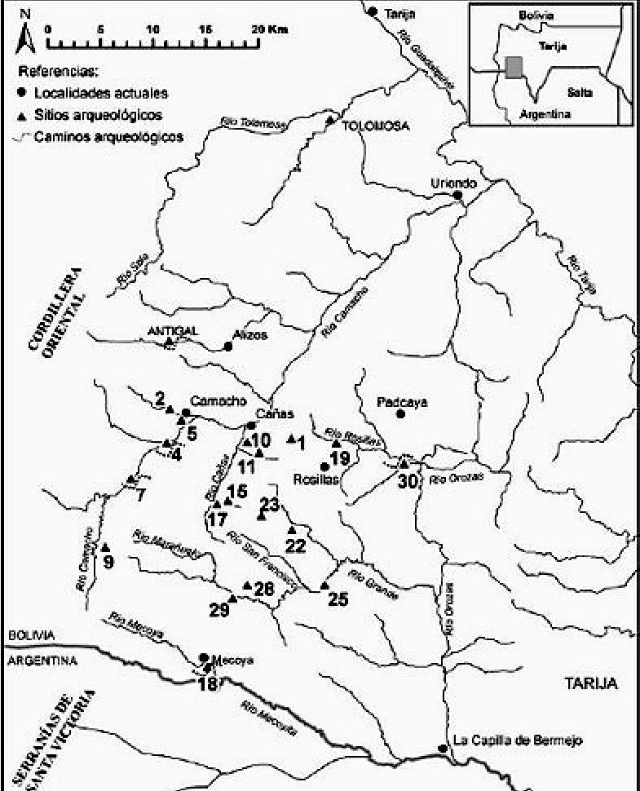



[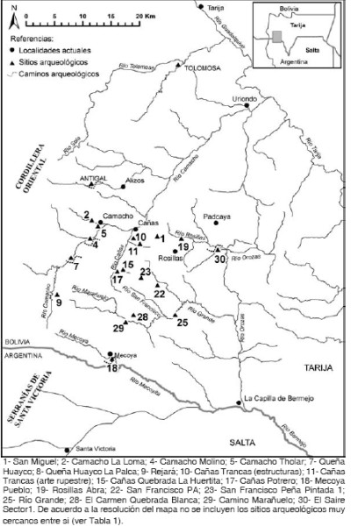](http://www.scielo.org.ar/img/revistas/iant/v11n1/a05f1.jpg)**Figure 1.** Archaeological sites mentioned in the text.

These valleys are located in environments Tucuman-Bolivian forest, including vegetation units of semi-humid montane forest in cloudy areas, *Polylepis* forest (keñua), *Alnus acuminata* forest (white alder), *parlatorei Podocarpus* forest (pine the hill), *Acacia* thorn forest of *dig* (churqui) and *Prosopis* (mesquite) and areas of *Tipuana tipu* (TIPA) (Beck *et al.* 2001). This original vegetation has been largely replaced by other substitution. The woods were degraded by the influence of cattle, primarily cattle and goats, and the emergence of weeds. The logging and burning are other human actions that have affected forest formations. Farming is done on alluvial river terraces, in the case of irrigated crops, mainly potatoes, peppers, corn, grapes and other fruits (Beck *et al.* 2001).

Geomorphological studies conducted by Macklin *et al.* (2001) recorded various types of erosion in these valleys, but note that the main erosion dates back over a thousand years, having occurred further erosion periods several thousand years ago. They believe that "active erosion areas are only a small part of the surface of the central valley and across the southwest of the department" (Macklin *et al.* (2001: 7). In turn, Preston and Punch (2001) highlight the impressive erosion observed in numerous locations in the Tarija basin which, although is largely a result of natural processes of soil formation over millennia, think that is likely to have been accelerated because of human settlements and the introduction of European livestock (especially cattle, goats and sheep) by the Spanish in the sixteenth century.

**SURVEY**

The methodology used was the survey of selected areas of said valleys. In some cases data were the existence of archaeological remains in the area, in other sectors were surveyed of which there was no prior information. We also examined archaeological materials held by local residents. Always determined the position of the site (with GPS, Geographic and UTM systems). The photographic record was made ​​of the sites and materials. In most sites its plant structures was carried out in a preliminary way. The task of rock art survey was conducted by Lilo Methfessel (2001).

In specific cases was collected ceramic material found on the surface, forming a small sample that prevents the time raise generalizations. We chose to make a brief description of some attributes as decoration and surface treatments. The collected materials remain in Bolivia (Chaguaya Museum), except for a dozen sherds were selected for study of thin sections. Three of these samples were analyzed by Dr. Beatriz Cremonte (2007) and five by Ms. Patricia Sola (2008) and the results are summarized in Appendix 1. Furthermore, one of the sites in a sample was removed human bone was radiocarbon dating.

Then briefly presents some relevant data from archaeological sites have been recorded in the various valleys. The numbers in parentheses correspond to the list of geographic positions of the sites, which are detailed in [Table 1](http://translate.googleusercontent.com/translate_c?depth=1&ei=lyjjUJ-6CrHw0QGuyoCoDA&hl=en&prev=/search%3Fq%3D%2522El%2Bregistro%2Barqueol%25C3%25B3gico%2Bde%2Blas%2Bantiguas%2Bpoblaciones%2Bde%2Blos%2Bvalles%2Borientales%2Bde%2Bla%2BProvincia%2BArce,%2BTarija,%2BBolivia%2522%26hl%3Den%26lr%3D%26safe%3Doff%26tbo%3Dd%26as_qdr%3Dall&rurl=translate.google.ca&sl=es&u=http://www.scielo.org.ar/scielo.php%3Fscript%3Dsci_arttext%26pid%3DS1850-373X2010000100005&usg=ALkJrhi71R0oSzwmT4gJ_RLGAbpNFtMWPQ" \l "t1) .

[**Table 1**](http://www.scielo.org.ar/img/revistas/iant/v11n1/a05t1.gif) . Location of the sites mentioned in the text.

**Camacho Valley**

Camacho River is one of the most important waterways in the central valleys of Tarija. Born in the mountains south of Rejará and extends NE facing, for more than 80 miles to its confluence with the River Guadalquivir - Tarija.

In a deep valley area called La Loma (2) site was detected with a simple rectangular structures fortnight, with double stone walls. The sizes of the structures vary between 2.50 m and 4.50 x 6.70 x 3.90 m. The site could be defined as a semi-dispersed cluster or village, in an elevated position, with very good view of the surrounding area.

In Mill Camacho (3), together with a large rock on which traits were called "domes" [4](http://translate.googleusercontent.com/translate_c?depth=1&ei=lyjjUJ-6CrHw0QGuyoCoDA&hl=en&prev=/search%3Fq%3D%2522El%2Bregistro%2Barqueol%25C3%25B3gico%2Bde%2Blas%2Bantiguas%2Bpoblaciones%2Bde%2Blos%2Bvalles%2Borientales%2Bde%2Bla%2BProvincia%2BArce,%2BTarija,%2BBolivia%2522%26hl%3Den%26lr%3D%26safe%3Doff%26tbo%3Dd%26as_qdr%3Dall&rurl=translate.google.ca&sl=es&u=http://www.scielo.org.ar/scielo.php%3Fscript%3Dsci_arttext%26pid%3DS1850-373X2010000100005&usg=ALkJrhi71R0oSzwmT4gJ_RLGAbpNFtMWPQ" \l "4) (Methfessel and Methfessel 1998), was found in ceramic surface due to removal for cultivation work. We collected a sample of three ordinary fragments. Not far away, next to a paved section of the trail (4), is a rock with rock art engravings presenting abstract and figurative motifs, between them stands the figure of a zoomorphic possible representation of a monkey. The paved path sector corresponding to a stretch of road, pre-Inca likely that, as in other cases, was used during the time of Inca occupation.

In Tholar (5) there are long rectangular structures and stone walls. In the vicinity are despedre mounds, past and present. There are two rectangular structures of double walls, attached to each other. We collected a sample of 12 sherds found on the surface, most of them badly eroded. No decoration present.

In Qena Huayco several archaeological sites. Are observed paved trail stretches well preserved (6). In one section there is a crossing of these roads with a large rock (7). Possibly be other sections of the old Inca road, as both north (Alder and Tolomosa) and east (The Saire) is major Inca sites occupations. In this case the paths tarijeña Puna communicate with the west ( [Figure 2](http://translate.googleusercontent.com/translate_c?depth=1&ei=lyjjUJ-6CrHw0QGuyoCoDA&hl=en&prev=/search%3Fq%3D%2522El%2Bregistro%2Barqueol%25C3%25B3gico%2Bde%2Blas%2Bantiguas%2Bpoblaciones%2Bde%2Blos%2Bvalles%2Borientales%2Bde%2Bla%2BProvincia%2BArce,%2BTarija,%2BBolivia%2522%26hl%3Den%26lr%3D%26safe%3Doff%26tbo%3Dd%26as_qdr%3Dall&rurl=translate.google.ca&sl=es&u=http://www.scielo.org.ar/scielo.php%3Fscript%3Dsci_arttext%26pid%3DS1850-373X2010000100005&usg=ALkJrhi71R0oSzwmT4gJ_RLGAbpNFtMWPQ" \l "f2) ).

[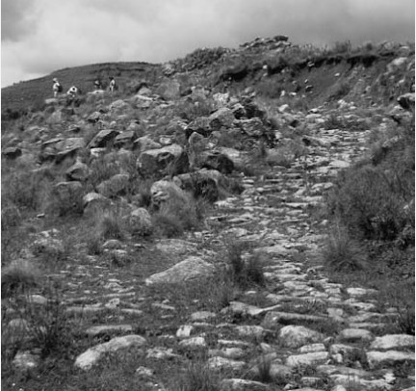](http://www.scielo.org.ar/img/revistas/iant/v11n1/a05f2.jpg)**Figure** 2. Sector Huayco paved road in Qena.

Another archaeological site is for flute Huaico-La Palca, a semi-conglomerate stone wall structures, semi-rectangular shapes and circular (8). These correspond to large structures, which are attached to the smaller ones. Here we highlight some constructions with large flat rocks placed on three stones. We reported on the prior existence of numerous rectangular stones type "menhirs", [5](http://translate.googleusercontent.com/translate_c?depth=1&ei=lyjjUJ-6CrHw0QGuyoCoDA&hl=en&prev=/search%3Fq%3D%2522El%2Bregistro%2Barqueol%25C3%25B3gico%2Bde%2Blas%2Bantiguas%2Bpoblaciones%2Bde%2Blos%2Bvalles%2Borientales%2Bde%2Bla%2BProvincia%2BArce,%2BTarija,%2BBolivia%2522%26hl%3Den%26lr%3D%26safe%3Doff%26tbo%3Dd%26as_qdr%3Dall&rurl=translate.google.ca&sl=es&u=http://www.scielo.org.ar/scielo.php%3Fscript%3Dsci_arttext%26pid%3DS1850-373X2010000100005&usg=ALkJrhi71R0oSzwmT4gJ_RLGAbpNFtMWPQ" \l "5) placed vertically, which on our visit to the site was observed in a few cases. However, site architecture, consider the age of it can greatly exceed the 1000 yr BP.

In Rejará (9) were four structures with stone walls of circular shape with a diameter of *ca.* 2.5 to 3 m and six rectangular structures of *ca.* 3.50 x 2.50 m. In its vicinity, ceramic material was detected on both sides of the road vehicle. These billing coarse fragments, good cooking surface smoothed. Two of them, in ways that could correspond to cylindrical foot vessels.

Reeds Valley  
It is a narrow gorge, between 150 and 350 m wide and about 12 km long, NS orientation. Cañas River has permanent water flows into the river Camacho. In the valley floor and alluvial terraces cultivated corn and wheat. There are only short plains and small hills suitable for installation sector human right, with a vegetation cover of grasses mixed-deciduous dry forest, since the left and the slopes are very steep sides. The survey, therefore, was directed at the valley bottom and on the right bank of the creek.  
The site Trancas (10) corresponds to a semi-conglomerate of some 30 structures of stone walls with double walls, occupying different levels of the hillside, where they have built many retaining walls. The structures have, for the most part, rectangular, although some circular. In both cases, the smaller structures are between 5 and 3 m. Inside one of these rectangular enclosures found a small circular structure (0.60 m in diameter) that had been excavated by looters, which, we were told, contained a burial. 13 ceramic fragments were found in the excavated hole, of which only three showed a purplish red color coverage; 19 fragments were collected on the outside of the circular structures, all without fancy decoration. One of these fragments corresponds to pasta Yavi-Chicha (Cremonte 2007, Appendix 1 shows C1). The large rectangular structures could correspond to cultivation boxes and pens.  
In the vicinity of this site, in a location higher on the hillside, were scattered rectangular and circular structures and rocks with engravings (13 and 14). In the Quebrada de Cañas (11 and 12) is located five and ten sites with rock engravings that have the characteristic called "domes" (Methfessel 2001).  
Going up the Quebrada de la Huertita was reached Cave 1 (15), known to locals as "Devil's Cave". It has almost 19 meters long, a maximum width of 8.30 m ceiling height reaches 2.40 m. Inside were three ceramic vessels on the surface and remains of other natural projections placed in the walls of the cave. One of the vessels has incised around the rim (Figure 3 b). On the right side of the cave, the sediment was removed by looting and human bones were seen scattered on the surface. A sample for dating bone which resulted in 2750 ± 70 BP (GX-29688, human bone, = -17 ‰). You can not make a direct association between human burials found in surface vessels and consider these correspond to later occupations.[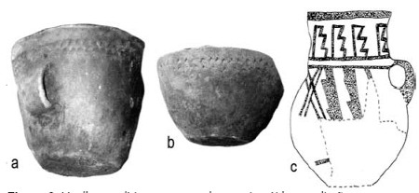](http://www.scielo.org.ar/img/revistas/iant/v11n1/a05f3.jpg)**Figura 3** . Vasijas posiblemente anteriores a los últimos mil años.

In the vicinity of the cave were detected two forwards. In one of them (C2) human bones were found scattered on the surface, the result of looting. At the other forward (C3) burials were also looted, in this case the graves were dug wells in the sediment and covered with stone slabs. The burials appear multiple individuals and adults in one of them, by the wall of the eaves was observed deformation tabular erect skull with long bones. On the surface there was a wooden paddle retreat inside one of the tombs.

Near the above on a third wing (C4) (16), was detected rock art. These abstract patterns: concentric circles and a meandering ( [Figure 4](http://translate.googleusercontent.com/translate_c?depth=1&ei=lyjjUJ-6CrHw0QGuyoCoDA&hl=en&prev=/search%3Fq%3D%2522El%2Bregistro%2Barqueol%25C3%25B3gico%2Bde%2Blas%2Bantiguas%2Bpoblaciones%2Bde%2Blos%2Bvalles%2Borientales%2Bde%2Bla%2BProvincia%2BArce,%2BTarija,%2BBolivia%2522%26hl%3Den%26lr%3D%26safe%3Doff%26tbo%3Dd%26as_qdr%3Dall&rurl=translate.google.ca&sl=es&u=http://www.scielo.org.ar/scielo.php%3Fscript%3Dsci_arttext%26pid%3DS1850-373X2010000100005&usg=ALkJrhi71R0oSzwmT4gJ_RLGAbpNFtMWPQ" \l "f4) d). The reasons have been painted in red on a black color natural support and are located in the roof eave and in high positions. Some of them are thinned.

[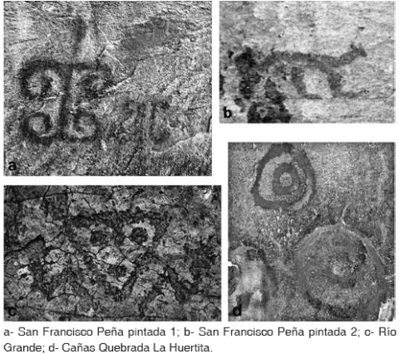](http://www.scielo.org.ar/img/revistas/iant/v11n1/a05f4.jpg)**Figure 4.** Some examples of rock art.

At the low end of the Gorge of the site was surveyed Huertita Potrero MV (17) with two types of structures. One of them is for circular and rectangular enclosures of stone walls. In some rocks that comprise the wall of a circular structures were detected that were made ​​recorded inside thereof ( [Figure 5](http://translate.googleusercontent.com/translate_c?depth=1&ei=lyjjUJ-6CrHw0QGuyoCoDA&hl=en&prev=/search%3Fq%3D%2522El%2Bregistro%2Barqueol%25C3%25B3gico%2Bde%2Blas%2Bantiguas%2Bpoblaciones%2Bde%2Blos%2Bvalles%2Borientales%2Bde%2Bla%2BProvincia%2BArce,%2BTarija,%2BBolivia%2522%26hl%3Den%26lr%3D%26safe%3Doff%26tbo%3Dd%26as_qdr%3Dall&rurl=translate.google.ca&sl=es&u=http://www.scielo.org.ar/scielo.php%3Fscript%3Dsci_arttext%26pid%3DS1850-373X2010000100005&usg=ALkJrhi71R0oSzwmT4gJ_RLGAbpNFtMWPQ" \l "f5) ). The other structures correspond to accumulations of stones placed in a circle, similar to the burial mounds of San Francisco, which is mentioned below. Know if that was his role in this case. Nearby, two newly plowed fields (Corner and Corner) was collected ceramic surface, four and 12 fragments, respectively. It corresponds to flattened, thick ceramic.

[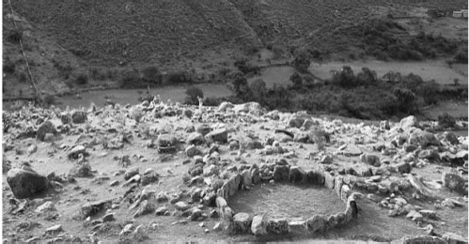](http://www.scielo.org.ar/img/revistas/iant/v11n1/a05f5.jpg)**Figure 5.** Cañas-Quebrada de La Huertita, MV Potrero site

Mecoya Valley  
It is a broad valley that extends from west to east with a vegetation of grasses and low scrub churquis essentially devoted to corn and sheep farming. We conducted a quick survey around the town of Mecoya (18), reaching the town of Mecoyita in Argentina. Mecoya near remains were found stone walls large rectangular structures (10 x 7 m 8 x 5 m) sparsely distributed and old walls and terraces. On the surface there were a few very eroded sherds. Recently, Delcourt (2007) recorded a stretch of a road linking Prehispanic the higher parts of the Cordillera Oriental Rejara with cobbled sections and retaining walls, passing through Mecoya and then east through the hills Tambillo and Ladders, where part of its course is carved into the rock and presented system bleachers and drainage channel, continuing until Bermejo Chapel.  
Rosillas Valley  
The valley is about 10 km long and an average width of 1.2 km, with a northwest-southeast orientation whose waters are not permanent. It has an almost unique vegetation thickets churquis except side streams where there is more varied vegetation. In the area called Open Rosillas (19) are rectangular structures recognized double stone walls, and mounds despedre grinding stone materials and ceramic surface, collecting nine fragments with red-violet coverage, three smoothed and polished one. Also located a large boulder with rock art, painted red motif (20). Both sites are very destroyed. In a plowed field (The Tower) 10 sherds were collected, of which only one had a bath or red-orange cover.  
In Rosillas, at the height of the stream Open de Cañas, one of the authors of this paper (PD), recorded an eave painted red, white and yellow with zoomorphic and geometric. In the 2001 survey Examined archaeological materials of great interest in the possession of a local person, rescue product on a site with previously looted. This item Seems to Overcome the space bounded by the Project and APPROPRIATE to early times. It is human Burials, Accompanied by various elements, Including corncobs, textiles, feathers, rope with red pigment plant land snails, snail shell accounts on. Also included a decorated ceramic vessel bicolor (red on buff) (Figure 3 c) relate to the características a piece stylistically registered in the Department of Santa Victoria, Skip (JC Balmas, personal communication 2007). Polychrome stepped motifs in different sites Vessels resources early moments in NW Argentina, with dates of around the beginning of the Christian era.  
San Francisco Valley  
It Differs from the surrounding valleys by a mixed grassland vegetation in some areas with bushes and small diverse floristic composition sparse mountain forests in the highlands and dense thickets churquis little on the people of San Francisco That is at the center of the depression.  
Near the town of San Francisco (22) recognized a site with numerous circular mounds of stones, which, in most cases, have been looted. They were, apparently, burial places. They have about 3 m in diameter and three feet high. It can be seen, inside which have been opened by the huaqueros AC rectangular structure. 1.10 x 0.60 m. In one of them a villager found a small ceramic pitcher and, in another, a vessel with incised decoration (Figure 3 a), 6 projectile points, a circular hub polished gray stone, a black stone whorls and mineral fragments . Nearby, in a plowed field eight sherds were collected without decoration.  
On the walls were closed Licerazu rock art. In one of them (PP1) (23) representations are distributed among five panels with paintings and engravings. There figurative motifs, including zoomorphic (stand a monkey painted etching and camels) and abstract motifs, concentric circles, triangles and concentric triangles, serpentine, among others (Figure 4a). The colors used are red, white, yellow and black. There are overlaps and the site is disturbed with current paintings. Another of the walls (PP2) (24) have motifs painted in red, between figurative and anthropomorphic is a representation of a feline (Figure 4b). Another wall corresponds to the so-called "Cave Champosa" Lilo and recorded by Carlos Methfessel in 2000, highlighting two grounds of "concentric lines" and triangles made in red and white paint. There are prints and stripes today.  
Rio Grande Valley  
This valley is deep, the river, permanent water, follows a northwest-southeast before flowing into the river up to Orosas La Merced and Fort Bell, with vegetation typical of humid mountain forests (Yungas). Because vegetation cover, the survey was limited to the areas closest to the people and, therefore, also more impacted. The archaeological site is located detected near the Rio Grande (25). These prints made on large blocks of type rocky outcropping in surface slab. Were recorded in two sectors. In one of them are abstract and figurative prints, standing out among the latter a pair of zoomorphic and anthropomorphic face formed by a triangle (Figure 4 c). In the other sector, which corresponds to a large flat rock block, there were numerous reasons recorded. In this case there are also abstract and figurative, but this highlights the various representations of camels, singly or in sets of 10 or 11 llamas. There anthropomorphic linear and geometric designs. Interestingly, several of the reasons recorded correspond to registered partner sites old trails in the western department of Tarija (Methfessel and Methfessel 1997). We were informed that currently pass through this place llama caravans coming from the Puna and head to the nearby jungle.  
Across the river stood a site with plenty of ceramic surface (26). The place had been cultivated and in the vicinity there are two stone buildings. One is rectangular, large and the other is an old stone-walled house. We collected a sample of 31 fragments of ceramic surface, recorded some of secondment Yavi-Chicha, with two imprints of textiles or basketry on its outer surface (quartz type Pozuelos) (Krapovickas 1977) (sample RG1). Also There are decorated in Black on White (Figure 6), in Which case (sample RG2) decoration broken lines spiraling black-brown color on white slip forward, possibly ceramic Chiriguana (Outes 1909). On These two types of ceramic petrographic Analyzes (Appendix 1).

[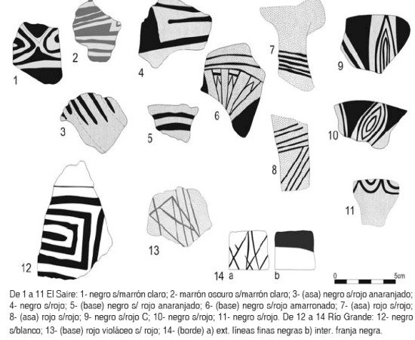](http://www.scielo.org.ar/img/revistas/iant/v11n1/a05f6.jpg)**Figure 6.** Fragments of pottery sites The Saire and Rio Grande.

**Valle de El Carmen**

You cross a small stream, west-east orientation, linking the valleys Rosillas Cañas and a permanent watercourse vegetation churquis grasslands and shrublands. The narrow gorge Blanca, located north of the town, rises steeply to the high plateau and mountain vegetation Licerazu with alders and kheñua. En esta quebrada, en el paraje conocido como Antigal (28), se detectaron unas 10 estructuras rectangulares de paredes de piedra, con muros dobles, ubicadas en los distintos niveles naturales del cerro. Hay también muros de contención que protegen los bordes de la ladera de la erosión. Se destaca una de las estructuras (5 x 3 m) cuyos muros denotan una cuidadosa construcción y cuyas piedras han sido seleccionadas. Se recolectó una muestra cerámica de 15 fragmentos, en su mayoría alisados toscos, aunque algunos son pulidos y un par con engobe rojo amarronado. El sitio se halla frente al cerro Ovejería y domina una amplia visión de la Quebrada. Algo mas abajo y en la ladera opuesta hay varias cuevas (27) en las que, nos informaron, había entierros. No se pudo constatar este dato por la dificultad de acceso a las mismas.

A ambos lados del sendero que comunica El Carmen con Marañuelo se registraron sectores donde se agrupan estructuras de piedras. Son concentraciones de piedras colocadas en forma circular. Sus medidas aproximadas son entre 1,50 o 1,90 m de diámetro y 1,30 m de alto. Se hallan en conjuntos de entre siete y 12 estructuras. Se desconoce su función ( [Figura 7](http://translate.googleusercontent.com/translate_c?depth=1&ei=lyjjUJ-6CrHw0QGuyoCoDA&hl=en&prev=/search%3Fq%3D%2522El%2Bregistro%2Barqueol%25C3%25B3gico%2Bde%2Blas%2Bantiguas%2Bpoblaciones%2Bde%2Blos%2Bvalles%2Borientales%2Bde%2Bla%2BProvincia%2BArce,%2BTarija,%2BBolivia%2522%26hl%3Den%26lr%3D%26safe%3Doff%26tbo%3Dd%26as_qdr%3Dall&rurl=translate.google.ca&sl=es&u=http://www.scielo.org.ar/scielo.php%3Fscript%3Dsci_arttext%26pid%3DS1850-373X2010000100005&usg=ALkJrhi71R0oSzwmT4gJ_RLGAbpNFtMWPQ" \l "f7) ). En el mismo camino se halló una roca con grabados lineales, en forma de canales que conectan "cúpulas" naturales (29). En un campo arado se recogió una muestra de cinco fragmentos alisados muy erosionados.

[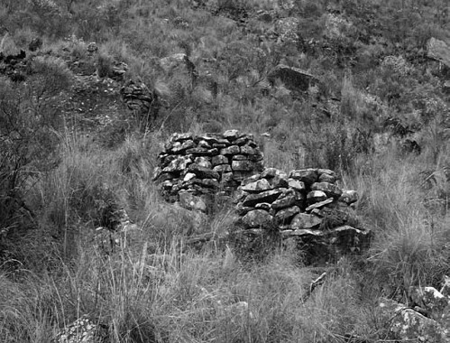](http://www.scielo.org.ar/img/revistas/iant/v11n1/a05f7.jpg)**Figure 7.** Structures Marañuelo Camino.

**Quebrada El Saire**

The Saire (30 and 31) is a comprehensive site about 10 ha (Delcourt 2001) with more than a hundred stone-walled structures. Ibarra Grasso (1973: 342), who visited the site, recognizes there called Chicha ceramic and lithic Tarija of Inca origin. Stresses the abundance of stone objects including mentions malachite beads, obsidian arrowheads of small size, polished axes, fountains and lots of whorls, ornaments and pendants with zoomorphic representations. Lopez Arellano (1984), who also recorded the site, considered as belonging to the "Culture Tarija". As stated earlier, Rendón (2004) described the site as the pottery from local, albeit within a "southern ceramic assemblage" which includes the regions of Yavi and Tupiza.

It was verified that the site is really destroyed by human action. Only did a quick survey, since it had been registered. We believe that, by the architecture of certain structures and the large number and variety of pottery found on the surface, this site records an Inca occupation. The site is crossed by a paved road, which has been partly destroyed by modern works. He got a sample of 192 ceramic fragments surface, which presents great diversity of materials and decorative techniques, including: purplish red slip polished black paint on red, black on brown, brownish black on red, black on orange-red, purplish black on red, red on red, subsections, etc.. ( [Figure 6](http://translate.googleusercontent.com/translate_c?depth=1&ei=lyjjUJ-6CrHw0QGuyoCoDA&hl=en&prev=/search%3Fq%3D%2522El%2Bregistro%2Barqueol%25C3%25B3gico%2Bde%2Blas%2Bantiguas%2Bpoblaciones%2Bde%2Blos%2Bvalles%2Borientales%2Bde%2Bla%2BProvincia%2BArce,%2BTarija,%2BBolivia%2522%26hl%3Den%26lr%3D%26safe%3Doff%26tbo%3Dd%26as_qdr%3Dall&rurl=translate.google.ca&sl=es&u=http://www.scielo.org.ar/scielo.php%3Fscript%3Dsci_arttext%26pid%3DS1850-373X2010000100005&usg=ALkJrhi71R0oSzwmT4gJ_RLGAbpNFtMWPQ" \l "f6) ). Some of the painted fragments are similar to those illustrated by Nielsen *et al.* (1999: 103) as belonging to the groups-Chicha Yavi and Colla.

These fragments are characterized by a decoration consisting of black painted solid areas alternating with concentric geometric patterns on a red background. The inner edges of black fillers present semicircles ( [Figure 6](http://translate.googleusercontent.com/translate_c?depth=1&ei=lyjjUJ-6CrHw0QGuyoCoDA&hl=en&prev=/search%3Fq%3D%2522El%2Bregistro%2Barqueol%25C3%25B3gico%2Bde%2Blas%2Bantiguas%2Bpoblaciones%2Bde%2Blos%2Bvalles%2Borientales%2Bde%2Bla%2BProvincia%2BArce,%2BTarija,%2BBolivia%2522%26hl%3Den%26lr%3D%26safe%3Doff%26tbo%3Dd%26as_qdr%3Dall&rurl=translate.google.ca&sl=es&u=http://www.scielo.org.ar/scielo.php%3Fscript%3Dsci_arttext%26pid%3DS1850-373X2010000100005&usg=ALkJrhi71R0oSzwmT4gJ_RLGAbpNFtMWPQ" \l "f6) [9, 10 and 11]). Similarly, petrographic analysis of fragments (Appendix 1, samples S1-S2-S3) can be included in the group of pastas Yavi-Chicha (Cremonte 2007).

**TRANSFER ACTIVITIES**

No attempt was made ​​to record only the diversity of the archaeological sites located in these valleys, but also sought to assess their conservation status and the possibility of preservation. Almost all surveyed sites show different degrees of impact, primarily anthropogenic. In some cases the sites are in very poor condition and other verify their destruction.

Sobre la base del conocimiento previo del impacto antrópico en los sitios de la región, tanto en Bolivia (Delcourt 2003) como en Argentina (Ventura 1999), se determinó llevar a cabo en ambos países Talleres de difusión sobre el valor del Patrimonio arqueológico de la región y la necesidad de preservarlo. Los mismos se han realizado en Tarija en el año 2002, a cargo de Cynthia Montes (CICUMA), en Salta, Orán e I. Irigoyen en el año 2003, y en las localidades rurales de Los Toldos (Departamento Santa Victoria) y Los Naranjos (Departamento Orán) en 2006. En estos casos los Talleres estuvieron a cargo de las Lics. Gabriela Guráieb y Teresa Civalero (INAPL) realizándose en colegios secundarios. Se debe destacar la necesidad de continuar con proyectos de difusión sobre la valoración y conservación del patrimonio arqueológico y el trabajo con las comunidades.

**CONSIDERACIONES FINALES**

The survey carried out in areas of the eastern valleys of Arce Province in southern Tarija has resulted in the registration of more than thirty different archaeological sites and features for different times. Although this project is to study populations faced in the last 1000 years, it was found that in the valleys prospected the archaeological record dating back to moments before that time. An AP dated 2750 confirms in a burial cave, like the materials listed in other caves and rock sites in surface structures. The diversity of sites that characterize the archaeological record of these valleys can be summarized in:

- Sites with structures for isolated settlements scattered in nearby fields, which are in different locations.

- Sites where structures are more concentrated, possibly forming scattered settlements, which are also located in relation to cultivation boxes. They are in different locations. These sites are possibly different times, in some cases prior to 1000 years before present.

- A large site, considered a conglomerate with Inca occupation.

- Sections of paved trails, possibly forming the network of roads that connected the Inca settlements nearby. As mentioned previously, many of these seem to correspond to sections paved previous times were modified during the Inca expansion in the region. In some cases the paths are associated with rock art. - Human burial sites in caves and overhangs. While this form of burial could be used at different times, the two cases on which we have information chronologically correspond to moments prior to 1000 years BP. These two early burials represent different ways, and one of them had a complex and diverse outfit, while the other did not record material associated with human remains.

- Sites of burials in mounds shaped structures of stone, forming cemeteries.

- Sites of burials within enclosures housing possibly.

- Rock art sites. Many sites were found in different formats and locations, such as eaves, isolated rocks, in large slabs, etc.. Furthermore, the techniques include engraving, painting or both in one place. The reasons are varied representing both zoomorphic, anthropomorphic, geometric, etc..  
- Sites with no visible construction materials but with surface scattering.  
This variety of the archaeological record in the southern valleys corresponds tarijeño surely a long development of the populations in the region. Also adding in Inca times and later a large diverse population due to the relocation conducted by the Inca state, which was later enlarged and complexified by the Spanish conquest.  
The relevance of these valleys in the past seems to manifest in their need for connection to the higher parts of the Cordillera Oriental. The finding of several stretches of paved roads that connect different archaeological sites of great importance and Inca occupations such as Tolomosa, Antigal of Alisos and El Saire seems to support this proposal.  
It highlights the continuity in occupations that have evidence clearly attributable to the Inca times along the south eastern valleys of Tarija, forming a line of settlements continues in Salta territory, although there have not yet registered sites and size ing the architectural characteristics detected in the valleys of Bolivia. This differential is interesting when considering future research regarding the processes of imperial domination in the region.  
The great diversity registered ceramic supports the idea of ​​a long occupation of the region, and the interaction with neighboring towns. It is recognized that during the expansion took place incaica different populations relocation processes. In this regard, the record of pottery attributed to the ceramic groups Yavi-Chicha, Colla, Inca and Chiriguana could correspond to that period. It is also noteworthy that some of the pottery found, both times to the late early and Inca, have been recorded in sites located on either side of the current Argentine-Bolivian border.  
The abundant rock art of these valleys tarijeños denotes variety of motifs and techniques (paintings and prints). Unlike what has been observed in the eastern valleys of Salta, where so far there have been a dozen sites with engravings only, although it is possible that this difference may correspond to sampling bias. Future research in the eastern valleys of both territories will complete the characterization of the archaeological record here presented.  
Acknowledgements  
A Pro-Yungas, CONICET, Carlos Methfessel and family. By late Father Ananias Barreto, who accompanied us one day of field work and gave us information on some of the sites. Members of the NGO CICUMA. At the Museum of Paleontology and Archaeology of Tarija. To Mrs. Adelaide for showing your home in San Francisco. Paula Granda by the abstract and Sonia Lanzelotti for help in the preparation of Table 1. A Beatriz Cremonte by performing and analyzing ceramic thin sections. A Patricia Sola for his advice on ceramic petrography. And Luis Borrero for their corrections and suggestions, and to the two anonymous reviewers.  
NOTES  
1-This project was conducted with a grant from the Foundation Pro-Yungas (2001). This work was originally written in 2003 for a book that was not published, therefore, considering that the data are of interest, we have expanded and updated.  
2. - These works, mentioned Delcourt (1996) and Ventura (2001), were carried out within a larger project on the use of space in the eastern valleys of Tarija and Salta, led by Dr. David Preston (Department of Geography, University of Leeds, England) and Mr. Carlos Reboratti (Department of Geography, University of Buenos Aires), within which was performed radiocarbon.  
3. - We refer to the project "Integration and disintegration in the Andean peasant of NO in eastern valleys of Bolivia and Argentina," directed by C. Reboratti (UBA) and D. Preston (Leeds U.) in 1996 and the First International Symposium Lowland, Pedemonte Andean and eastern Argentina and Bolivia (University of Jujuy) organized by A. Teruel and O. Jerez in 1997.  
4. - "It's called domes spherical voids, dug by percussion or scraping stone" (Methfessel and Methfessel 1998: 36).  
5 - This figure was entrusted to Philippe Delcourt by Father Ananias Barreto.  
6. - This type of decoration is similar to that recorded in a piece of Cerro Colorado site (Krapovickas 1977: 138, Print II.1).  
APPENDIX 1  
Sample C1. Reeds Valley. Trancas (10)  
Characterization of pasta: pasta yellowish brown, coarse textured compact due to the presence of large clasts that act as antiplastics. Clay matrix contains abundant and tiny flakes of mica that are arranged in a subparallel around the larger grains.  
Antiplastics: rounded clasts of shales and micaceous alteration illítica, which constitute the major elements (ca. 39%). The minor components are quartz (ca. 1.80%), plagioclase (ca. 1.80%), hornblende amphibole (ca. 0.30%) and sandstone (ca. 0.30%).  
This paste integrates the largest group typically contains 20 to 40% of altered shales, typical of the vessels Yavi-Chicha (Cremonte 2007).  
Sample C2. Reeds Valley. Trancas (10)  
Characterization of pasta: pasta brown clear with a 25% porosity antiplastics and estimated at 20%. The matrix is ​​very fine clay also contains micaceous flakes of sericite, muscovite and biotite. The particle size of the components determines a medium texture.  
Characterization antiplastics: clasts of lithic fragments (ca. 99.50%) composed of material "ferruginous" that could be derived from sedimentary or hematite pigment fragments (either pure or in association with sedimentary material). Most of these components have different shapes (circular, ellipsoidal or irregular) and are well rounded. Size: 0.05 to 1.50 mm.  
In addition, there are tiny and few well rounded grains of quartz and plagioclase fraction ranging to very fine sand silt.  
Macroscopically, reddish clasts distinguished that might correspond with the addition of lytic ferruginous sand or be the result of grinding and adding hematite-rich materials. Based on the features observed in the thin section, can not determine which was the technique used in the preparation of the clay mass (Sola 2008).  
Displays RG1. Site Rio Grande  
Characterization of pasta: pasta reddish brown medium with ca. Antiplastics 25% and a porosity of approximately 20%. The matrix contains little material fine clay silt fraction (quartz, feldspar, iron oxide pellets, sericite and biotite). The texture of the dough is thicker and is determined by the components that reach sizes larger coarse sand fraction (greater than 1mm).  
Characterization antiplastics: lithic clasts or fragments lithoclasts (ca. 90%) of sedimentary and metamorphic varied compositions and shapes, from subangular to well rounded. Predominantly internal lithic fragments of very fine-grain claystones and shales and also sandstone clasts (quartzite etc.), iron oxide thin shales and schists subordinates. Size: 0.25 to 2.25 mm.  
There were also grains of alkali feldspar (orthoclase and microcline) (ca. 5%) angular to well rounded (size: 0.03 to 0.88 mm) and plagioclase, quartz (ca. 4%) in crystals very angular to subrounded (size: 0.03 to 0.88 mm) and small grains of hematite (ca. 1%) well rounded (size: 0.05 to 0.12 mm) (Sola 2008).  
Displays RG2. Site Rio Grande  
Characterization of pasta: pasta buff clear which distinguishes a core composed of grayish brown hue ca. Antiplastics 25%, with 35% porosity estimated. The clay matrix contains very little material fine silt fraction with pellets of hematite and traces of sericite. The texture is coarse pulp.  
Antiplastics Characterization: clasts lytic fragments (ca. 97%) of various shapes and compositions, subangular to well rounded. Predominantly of shales and sandstones lithoclasts, so there are subordinate claystones, ferruginous fragments, quartz and muscovite schists, slates, and very few fragments banded mica schist with carbonate alteration. Size: 0.07 to 2.05 mm.  
There were also quartz clasts (ca. 1%) to well rounded angular (size: 0.03 to 0.53 mm) and hematite (ca. 1%) rounded pellets (size: 0.05 to 0, 15 mm).  
The textural and compositional characteristics of this paste suggest the possible addition of sand to the clay matrix lytic (Sola 2008).  
Displays RG3. Site Rio Grande  
Characterization of pasta: pasta with dark auburn ca. Antiplastics 25% and 25% porosity estimated. The fine clay matrix is ​​opaque for the content of iron oxide (hematite) microparticulate rounded. The texture is coarse pulp.  
Antiplastics Characterization: this paste comprises grains or minerals and lithoclasts clasts in equivalent proportions. The clasts of lithic fragments (ca. 50%) are angular to well rounded; fragments predominate claystones, siltstones and sandstones of various compositions, also contains some clasts of slate, mica schist (muscovite) and quartz fragments and traces of granite. Size: 0.10 to 2.50 mm.  
Among the minerals, there are two types cristaloclastos alkali feldspar (orthoclase and microcline) (ca. 25%) angled to subrounded (size: 0.06 to 0.55 mm) of quartz (ca. 23%) to very sharp well rounded (size: 0.03 to 0.83 mm), plagioclase (ca. 1%) angular to subrounded (size: 0.06 to 0.38 mm) and hematite (ca. 1%) in tiny rounded granules (size: 0.25 mm) (Sola 2008).  
Sample S1. Site The Saire  
Characterization of pasta: pasta brown to reddish brown with ca. Antiplastics 30%, the calculated porosity is about 20%. The fine clay matrix contains abundant material fine silt fraction (quartz, feldspar, mica, iron oxide red, biotite, muscovite and sericite). The texture of the dough is thicker depending on the granulometry of the lithic antiplastics in some cases exceed 2 mm.  
Characterization antiplastics: irregular clasts of lithic fragments (ca. 98%), angular to subrounded, mainly by metasedimentary ferruginous compounds containing grains of quartz and mica (biotite and muscovite), so subordinate phyllites are scarce. Size: 0.10 to 2.87 mm.  
Among cristaloclastos are quartz (ca. 1%) (size: 0.03 to 0.16 mm), hematite (ca 0.1%) (size: 0.03 to 0.10 mm) and traces of plagioclase, biotite and muscovite included in the fine sand fraction.  
The textural and compositional features seen suggest that this paste may have been prepared with the addition of crushed rock, the metasedimentary ferruginous, but it is a trait very difficult to prove.  
While pasta is not equal, this ceramic saves "some" resemblance to the paste sample AA-1 (Antigal of Alisos), the differences are mainly in the composition of the raw material and in some percentage lithic minerals, especially quartz and hematite. However, both ceramic bodies look similar despite their macroscopic features are also very different (Sola 2008).  
Sample S2. Site The Saire  
Characterization of pasta: pasta evenly brown, porous and coarse texture. The bottom has hearty pasta quartz and muscovite flakes that disintegrated sandstone proceed.  
Antiplastics: the majority are lithoclasts antiplastics subrounded sandstone of various sizes (which constitute about 20%). The minor components are quartz, muscovite and plagioclase.  
In this paste, as shown in a very similar, from the site of Alisos Antigal (Tarija 4AA), inclusions clearly observed with the naked eye sandstones correspond to very fine grain internal differ from shales altered.  
They make an interesting variant within the "family" that characterize the style pastas Yavi-Chicha (Cremonte 2007).  
Sample S3. Site The Saire  
Characterization of pasta: pasta fine textured brown and fairly compact with abundant mica flakes subparalelamente arranged around the larger grains (antiplástico). This is an intermediate composition paste with respect to the composition of the inclusions described for the other samples (1C, 2 S, 4AA), and which contains ca. 14% of altered mudstones, ca. 6.5% of fine sandstones, ca. 3.6% quartz, ca. 1.5% of plagioclase and ca. 1% hornblende.  
Integrates Sub-Chicha Yavi pasta thinner and compact with less altered mudstones and sandstones (Cremonte 2007).

**REFERENCIAS CITADAS**

1. Arellano López, J. 1984 La Cultura Tarija: Aportes al conocimiento de los señoríos regionales del sur boliviano. *Arqueología Boliviana* 1: 73-81. [ [Links](javascript:void(0);) ]

2. Barreto, A. 1960 Apuntes de la arqueología de Tarija. Documentos personales. En archivo Museo de Chaguaya. Chaguaya, Tarija. MS. [ [Links](javascript:void(0);) ]

3. Bass Werner, P. 1995 El arte rupestre de Tarija. Informe a la DINAR, Tarija. MS. [ [Links](javascript:void(0);) ]

4. Beck, S., N. Paniagua Zambrana, M. Yevara Gárate y M. Liberman 2001 La vegetación y uso de la tierra del Altiplano y de los Valles en el Oeste del Departamento de Tarija, Bolivia. En *Historia, Ambiente y Sociedad en Tarija, Bolivia* , editado por S. Beck, N. Paniagua y D. Preston, pp. 47-93. Instituto de Ecología. Universidad Mayor de San Andrés, La Paz, Bolivia y School of Geography, University of Leeds, Reino Unido. [ [Links](javascript:void(0);) ]

5. Beierlein de Gutiérrez, M.2007 El Altiplano de Sama (Tarija, Bolivia) y su integración al ámbito Chicha-Inca: nuevos avances de investigación. En *Actas del XVI Congreso Nacional de Arqueología Argentina* , Tomo II: 183-187. Facultad de Humanidades y Ciencias Sociales, Universidad Nacional de Jujuy, Jujuy. [ [Links](javascript:void(0);) ]

6. Coronel, D., M. Jiménez y H. Puentes 1995 Informe de trabajo de campo realizado en el sitio "Pueblo Viejo", Tarija, Bolivia. Escuela de Arqueología, Universidad Nacional de Catamarca. MS. [ [Links](javascript:void(0);) ]

7. Delcourt , P. 1996 Rapport du métrage et des sondages effectues sur le site d'Antigal (Bolivia) entre le 27 mars 1996 et le 05 avril 1996. En archivo Museo de Chaguaya. Chaguaya, Tarija. MS. [ [Links](javascript:void(0);) ]

8. Delcourt , P. 2001 Un inventario arqueológico preliminar en el Departamento de Tarija. En *Historia, Ambiente y Sociedad en Tarija, Bolivia* , editado por S. Beck, N. Paniagua y D. Preston, pp. 9-23. Instituto de Ecología, Universidad Mayor de San Andrés, La Paz, Bolivia y School of Geography, University of Leeds, Reino Unido. [ [Links](javascript:void(0);) ]

9. Delcourt , P. 2003 Panorama de la arqueología en el Departamento de Tarija, Bolivia. En *La mitad verde del Mundo Andino. Investigaciones arqueológicas en la vertiente oriental de los Andes y las tierras bajas de Bolivia y Argentina* , editado por G. Ortiz y B. Ventura, pp. 205-228. UNJu, Jujuy. [ [Links](javascript:void(0);) ]

10. Delcourt , P. 2007 Estudio de los caminos precolombinos de La Patanka y La Escalera. Informe para la Secretaría de Turismo y Cultura de la Prefectura de Tarija. Tarija. MS. [ [Links](javascript:void(0);) ]

11. Delcourt , P. 2008 Panorama de la Arqueología de Tarija. En archivo Museo de Chaguaya. Chaguaya, Tarija. MS. [ [Links](javascript:void(0);) ]

12 Fernández Distel, A. y C. Methfessel 1999 Mapa Arqueológico del Triángulo del Bermejo. Informe presentado a COREBE. MS. [ [Links](javascript:void(0);) ]

13. Ibarra Grasso, DE1944 Ensayo sobre la arqueología boliviana. *Relaciones de la Sociedad Argentina de Antropología* 4: 133-150. [ [Links](javascript:void(0);) ]

14. Ibarra Grasso, DE1973 *Prehistoria de Bolivia* . Editorial Los amigos del libro, La Paz. [ [Links](javascript:void(0);) ]

15. Krapovickas, P.1977 Arqueología de Cerro Colorado. Departamento Yavi, Provincia de Jujuy, República Argentina. En *Obra del Centenario del Museo de La Plata, Tomo* II, pp. 123-148. La Plata. [ [Links](javascript:void(0);) ]

16.Macklin, M., G. Maas, J. Warburton, J. Woodwward, E. Meldrum y D. Preston 2001 Historia de la formación de los paisajes de Tarija. En *Historia, Ambiente y Sociedad en Tarija, Bolivia* , editado por S. Beck, N. Paniagua y D. Preston, pp. 1-7. Instituto de Ecología, Universidad Mayor de San Andrés, La Paz, Bolivia y School of Geography, University of Leeds, Reino Unido. [ [Links](javascript:void(0);) ]

17. Methfessel, C. y L. Methfessel 1997 Arte Rupestre de la "Ruta de la Sal" a lo largo del Río San Juan del Oro. *Boletín de la SIARB* 11: 76-84. [ [Links](javascript:void(0);) ]

18. Methfessel, C. y L. Methfessel 1998 Cúpulas en Rocas de Tarija y Regiones vecinas. Primera aproximación. *Boletín de la SIARB* 12: 36-47. [ [Links](javascript:void(0);) ]

19. Methfessel, L. 2001 Registro del Arte Rupestre. Altas Cuencas de los ríos Bermejo y Tarija. Región Quebrada Cañas-Camacho-Rosillas-San Francisco-El Carmen. Proyecto Pro-Yungas. Informe presentado al SIARB. MS. [ [Links](javascript:void(0);) ]

20. Michel López, M. 2000 Diagnostico Arqueológico de la Reserva Biológica Cordillera de Sama (primera parte). Informe presentado a PROMETA. MS. [ [Links](javascript:void(0);) ]

21. Michel López, M., P. Ayala R., D. Gutierrez O., M. Beierlein de G., S. Calla Maldonado y G. Palacios 2005 Los Chichas preincaicos del sur de Bolivia y noroeste de la Argentina. *Pacarina* 4: 81-96. [ [Links](javascript:void(0);) ]

22. Nielsen, A., M. Vázquez, J. Avalos y C. Angiorama1999 Prospecciones arqueológicas en la Reserva "Eduardo Avaroa" (Sud Lípez, Depto. Potosí, Bolivia). *Relaciones de la Sociedad Argentina de Antropología* XXIV: 95-124. [ [Links](javascript:void(0);) ]

23. Oliveto, G. 2004 Caminantes de Sierra y Selva: Identidad y frontera en el sur andino, siglo XVI. Tesis de Licenciatura en Historia no publicada. Facultad de Filosofía y Letras, Universidad de Buenos Aires. [ [Links](javascript:void(0);) ]

24. Ortiz, G. y B. Ventura (editoras) 2003 *La Mitad Verde del Mundo Andino. Investigaciones arqueológicas en la vertiente oriental de los Andes y las Tierras bajas de Bolivia y Argentina* . EdiUnju, Universidad Nacional de Jujuy, Jujuy. [ [Links](javascript:void(0);) ]

25. Outes, F. 1909 La cerámica chiriguana. *Revista del Museo de La Plata,* Tomo XVI (segunda serie) tomo III: 121-136. [ [Links](javascript:void(0);) ]

26. Posnansky, A.1947 El Hombre Prehistórico de Tarija y las manifestaciones de su cultura material. La ciudad de Tullku-Marka. En *Actas del XXVII Congreso Internacional de Americanistas* , vol. 1, pp. 183-190. Lima. [ [Links](javascript:void(0);) ]

27. Presta, AM 2001 "Hermosos, fértiles y abundantes". Los valles centrales de Tarija y su población en el siglo XVI. En *Historia, Ambiente y Sociedad en Tarija, Bolivia* , editado por S. Beck, N. Paniagua y D. Preston, pp. 25-39. Instituto de Ecología, Universidad Mayor de San Andrés, La Paz, Bolivia y School of Geography, University of Leeds, Reino Unido. [ [Links](javascript:void(0);) ]

28. Presta, AM y M. del Río1993 Reflexiones sobre los Churumatas del Sur de Bolivia, Siglos XV-XVII. *Memoria Americana* 2: 41-49. [ [Links](javascript:void(0);) ]

29. Preston, D. and S. Punch 2001 Estrategias de vida del hogar, sistemas de producción y medio ambiente: el valle Camacho, Bolivia. En *Historia, Ambiente y Sociedad en Tarija, Bolivia* , editado por S. Beck, N. Paniagua y D. Preston, pp. 95-122. Instituto de Ecología, Universidad Mayor de San Andrés, La Paz, Bolivia y School of Geography, University of Leeds, Reino Unido. [ [Links](javascript:void(0);) ]

30. Raffino, R., D. Gobbo y A. Iácona 2006 De Potosí y Tarija a la Frontera Chiriguana. *Folia Histórica del Nordeste* 16: 83-130. Resistance. [ [Links](javascript:void(0);) ]

31. Rendón, P. 2004 Una aproximación a la arqueología de Tarija: El sitio Saire, estudio de las singularidades de su cerámica y la relación de esta con otros conjuntos. Tesis de grado inédita. Universidad Mayor de San Andrés, Facultad de Ciencias Sociales, Arqueología - Antropología, La Paz. [ [Links](javascript:void(0);) ]

32. Rosen, E. von 1990 *Un mundo que se va* . Universidad Nacional de Jujuy, San Salvador de Jujuy. [ [Links](javascript:void(0);) ]

33. Solá, P. 2008 Análisis microscópico de cerámica arqueológica. Proyecto de investigación arqueológica ambiente de Yungas (Argentina y Bolivia). En archivo Instituto de Arqueología, Facultad de Filosofía y Letras, UBA.MS. [ [Links](javascript:void(0);) ]

34. Ventura, BN 1999 Arqueología de los valles ubicados al oriente de las Serranías de Zenta y Santa Victoria, Salta. Tesis Doctoral inédita. Facultad de Filosofía y Letras, Universidad de Buenos Aires, Ciudad Autónoma de Buenos Aires. [ [Links](javascript:void(0);) ]

35. Ventura, BN 2001 Los últimos mil años en la arqueología de las Yungas. En *Historia Argentina Prehispánica* , Tomo I, editado por E. Berberián y A. Nielsen, pp. 447-492. Editorial Brujas, Córdoba. [ [Links](javascript:void(0);) ]

© *2013 Universidad Nacional del Centro de la Provincia de Buenos Aires. Facultad de Ciencias Sociales*   
  
Avda. del Valle 5737   
(B7400JWI) - Olavarría - Pcia. de Buenos Aires   
Republic of Argentina